UNITED STATES
SECURITIES AND EXCHANGE COMMISSION
Washington, DC 20549

SCHEDULE 14A
PROXY STATEMENT PURSUANT TO SECTION 14(a) OF THE
SECURITIES EXCHANGE ACT OF 1934
(Amendment No. )

Filed by the Registrant☒
Filed by a party other than the Registrant☐
Check the appropriate box:

☐ | Preliminary Proxy Statement
☐ | Confidential, for Use of the Commission Only (as permitted by Rule 14a-6(e)(2))
☐ | Definitive Proxy Statement
☒ | Definitive Additional Materials
☐ | Soliciting Material under §240.14a-12

Petco Health and Wellness Company, Inc.
(Name of Registrant as Specified In Its Charter)
(Name of Person(s) Filing Proxy Statement, if other than the Registrant)
Payment of Filing Fee (Check all boxes that apply):

☒ | No fee required
☐ | Fee paid previously with preliminary materials
☐ | Fee computed on table below in exhibit required by Item 25(b) per Exchange Act Rules 14a-6(i)(1) and 0-11

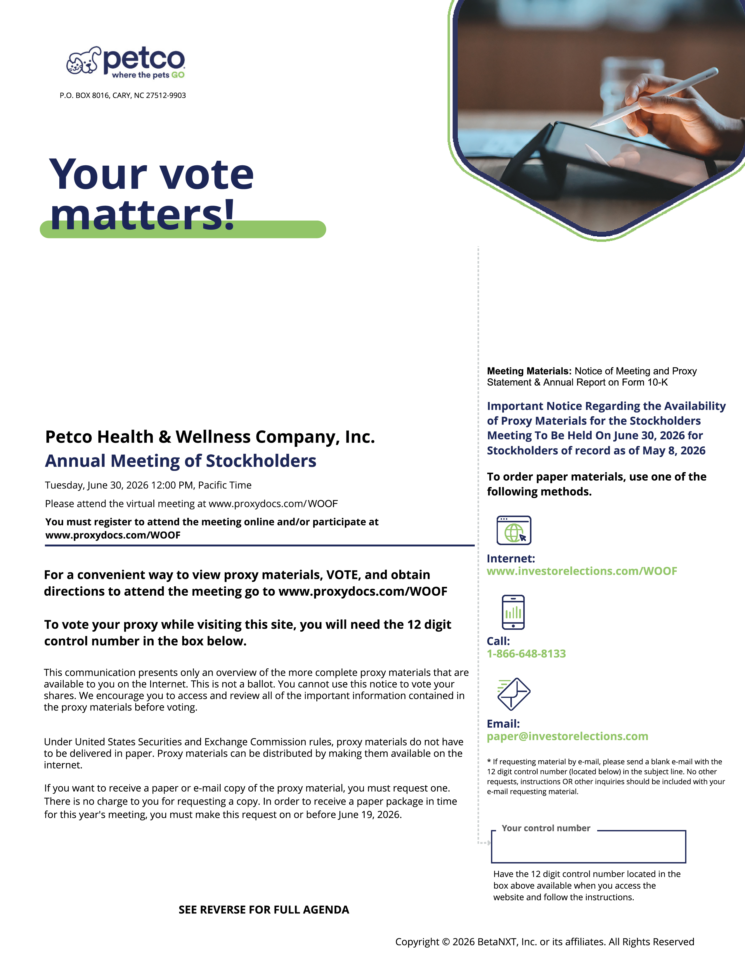
petco where the pets GO P.O. BOX 8016, CARY, NC 27512-9903 Your vote matters! Petco Health & Wellness Company, Inc. Annual Meeting of Stockholders Tuesday, June 30, 2026 12:00 PM, Pacific Time Please attend the virtual meeting at www.proxydocs.com/ WOOF You must register to attend the meeting online and/or participate at www.proxydocs.com/WOOF For a convenient way to view proxy materials, VOTE, and obtain directions to attend the meeting go to www.proxydocs.com/WOOF To vote your proxy while visiting this site, you will need the 12 digit control number in the box below. This communication presents only an overview of the more complete proxy materials that are available to you on the Internet. This is not a ballot. You cannot use this notice to vote your shares. We encourage you to access and review all of the important information contained in the proxy materials before voting. Under United States Securities and Exchange Commission rules, proxy materials do not have to be delivered in paper. Proxy materials can be distributed by making them available on the internet. If you want to receive a paper or e-mail copy of the proxy material, you must request one. There is no charge to you for requesting a copy. In order to receive a paper package in time for this year's meeting, you must make this request on or before June 19, 2026. SEE REVERSE FOR FULL AGENDA Meeting Materials: Notice of Meeting and Proxy Statement & Annual Report on Form 10-K Important Notice Regarding the Availability of Proxy Materials for the Stockholders Meeting To Be Held On June 30, 2026 for Stockholders of record as of May 8, 2026 To order paper materials, use one of the following methods. Internet: www.investorelections.com/WOOF Call: 1-866-648-8133 Email: paper@investorelections.com * If requesting material by e-mail, please send a blank e-mail with the 12 digit control number (located below) in the subject line. No other requests, instructions OR other inquiries should be included with your e-mail requesting material. Your control number Have the 12 digit control number located in the box above available when you access the website and follow the instructions. Copyright © 2026 BetaNXT, Inc. or its affiliates. All Rights Reserved

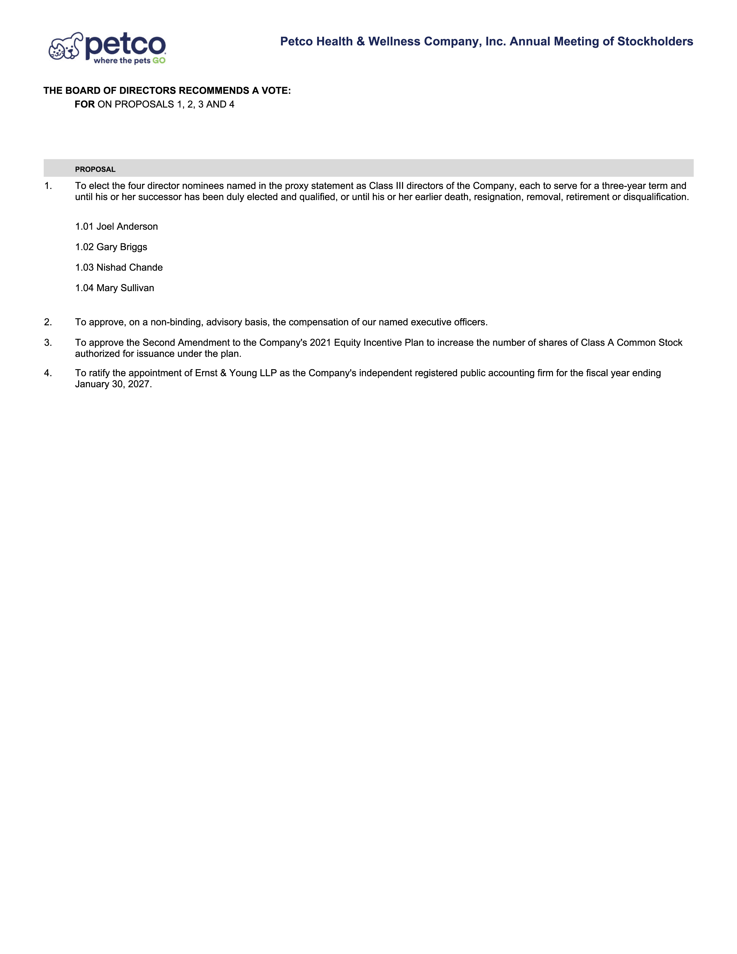
petco where the pets GO Petco Health & Wellness Company, Inc. Annual Meeting of Stockholders THE BOARD OF DIRECTORS RECOMMENDS A VOTE: FOR ON PROPOSALS 1, 2, 3 AND 4 PROPOSAL 1. To elect the four director nominees named in the proxy statement as Class III directors of the Company, each to serve for a three-year term and until his or her successor has been duly elected and qualified, or until his or her earlier death, resignation, removal, retirement or disqualification. 1.01 Joel Anderson 1.02 Gary Briggs 1.03 Nishad Chande 1.04 Mary Sullivan 2. To approve, on a non-binding, advisory basis, the compensation of our named executive officers. 3. To approve the Second Amendment to the Company's 2021 Equity Incentive Plan to increase the number of shares of Class A Common Stock authorized for issuance under the plan. 4. To ratify the appointment of Ernst & Young LLP as the Company's independent registered public accounting firm for the fiscal year ending January 30, 2027.

